**Task 2 Development – Tom H**

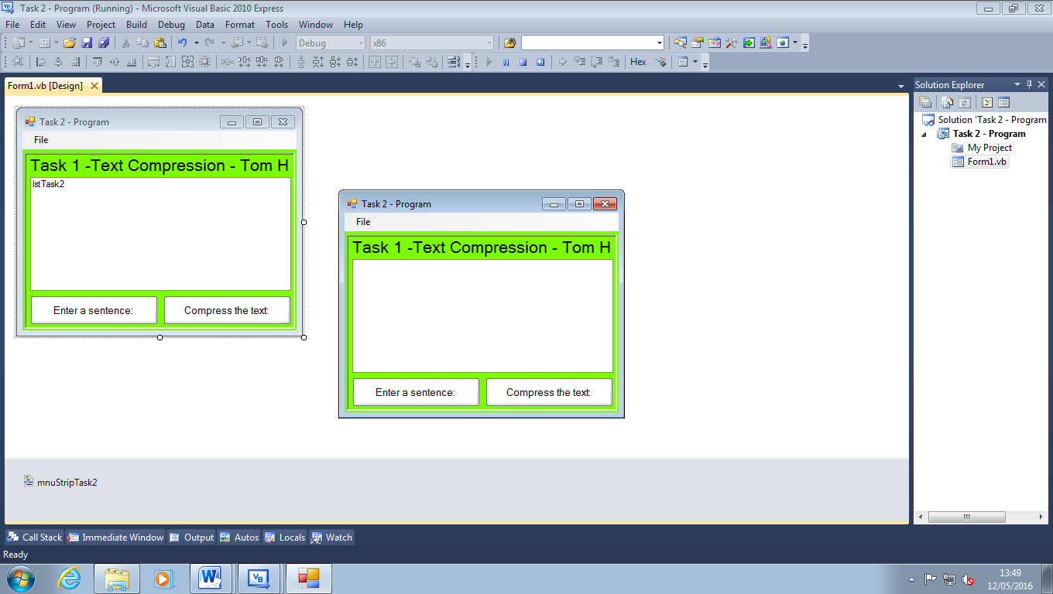

I have designed my program for the task using a simplistic design and using only two buttons. Also, I added a panel to the back of my user interface to add a more 3-dimensional fell to the program. The colour that I have chosen adds a positive vibe, however, I may change the colour later on as it’s quite bright and could be unpleasant to the eye after extended use.

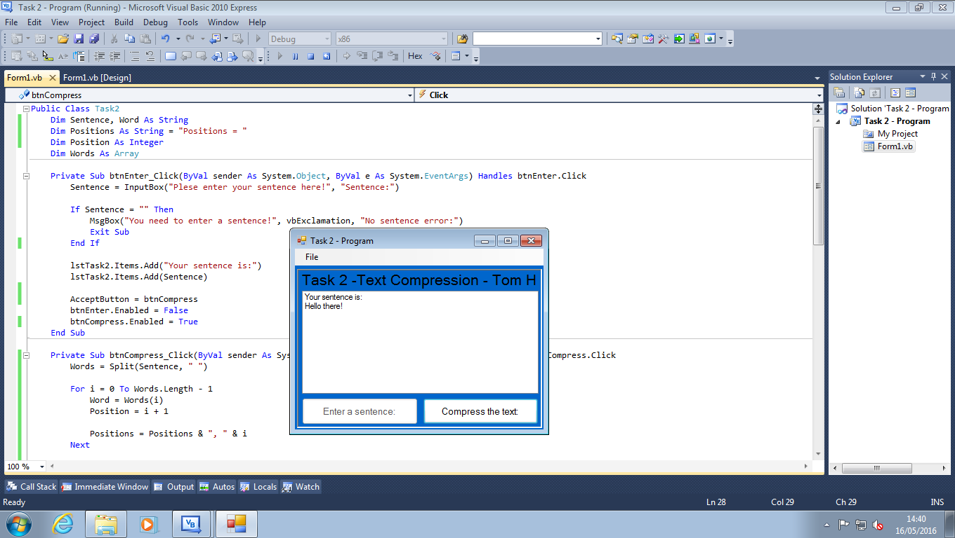

I have extended my program in the fact I can now enter a sentence and the buttons switch around accordingly to when you use them. My compression button is relatively basic as it splits the sentence and gives each word a number. I have also changed the colour scheme to a dark, navy blue which is more pleasant to look at.

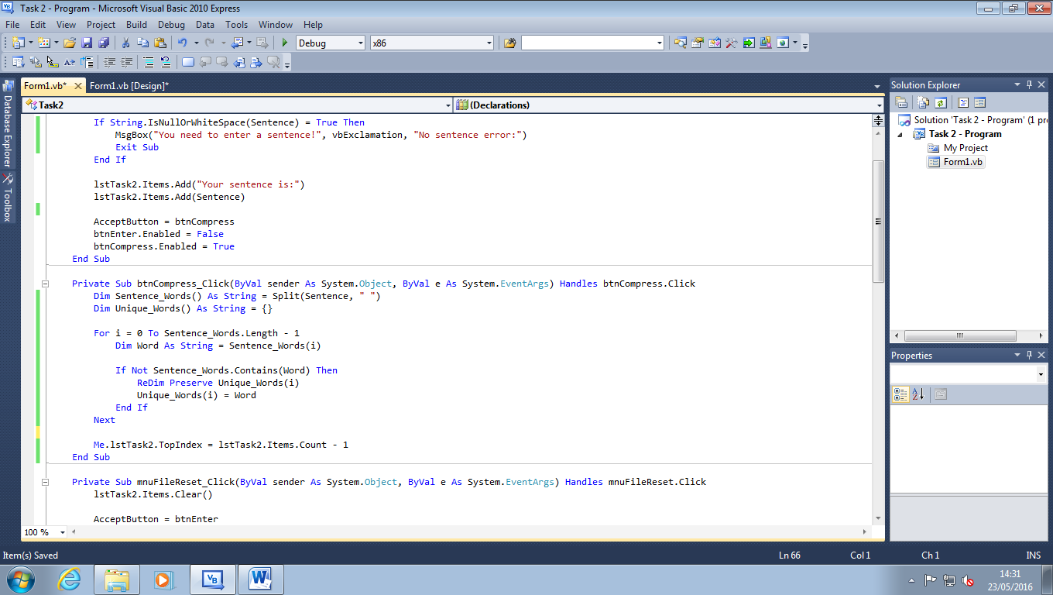

I have coded my program to loop through the array of words in the sentence entered and the check if they have been entered into the unique words array. If they have then the program will resize the array and add the word to the unique words array.

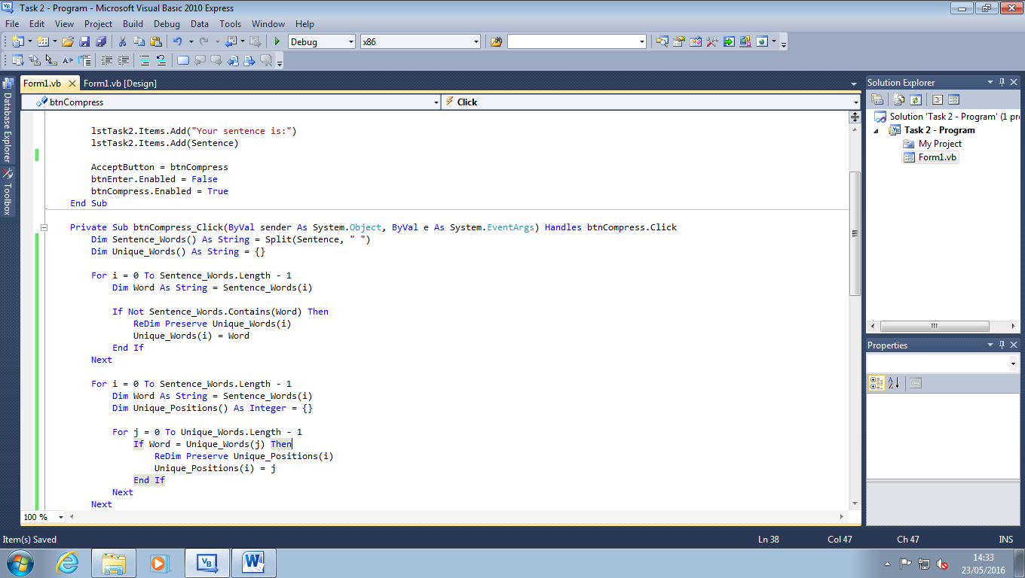

My program can now search through the sentence words array, pick out the next chronological word, loop through the unique words array and locate its position. I now need to find a way of outputting the location to a place where the user can see it.

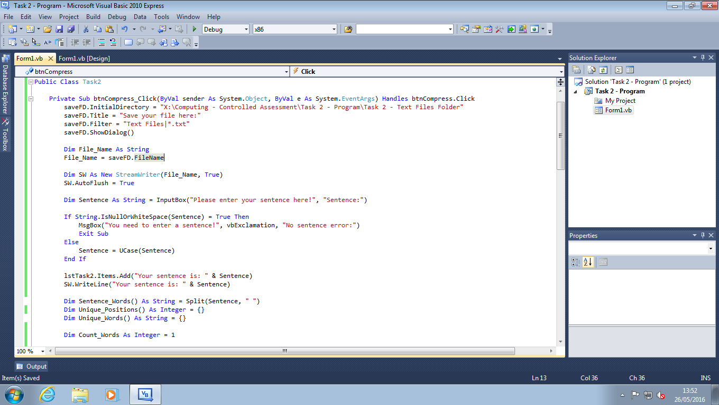

I have combined the two buttons together to make the program easier to use. I have also coded the save file dialogue box so the stream writer, which I have also coded, can write to a file.

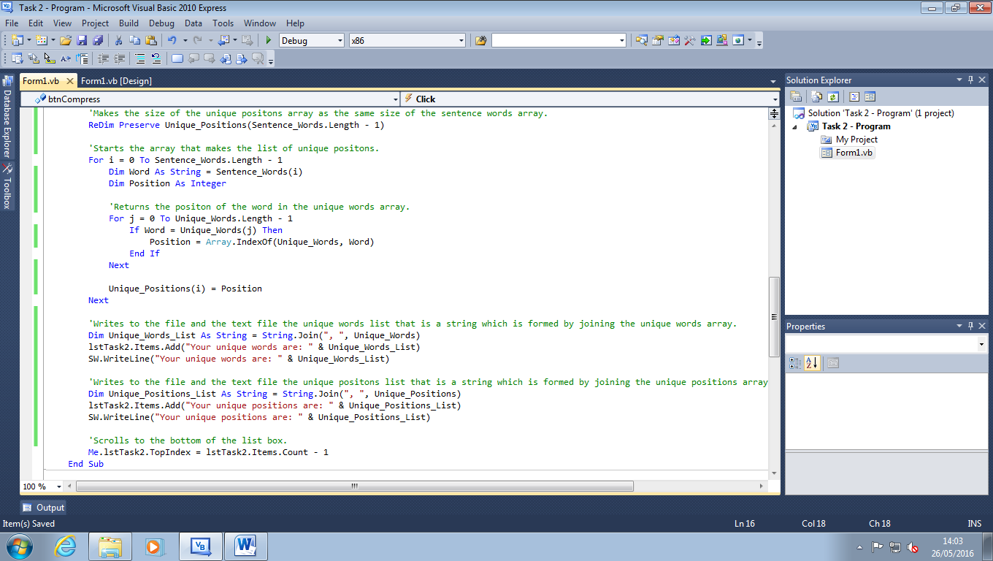

I have changed the loop so it returns the position of each word in the sentence words array by searching for its position from the unique words array. In addition to this, it writes to the list box and the text file by joining the arrays into a string. I have also commented my code.